

**AGENDA**

* **OBJECTIVE AND GOALS**
* **GHANT CHART**
* **ABSTRACT**
* **LITERATURE SURVEY**
* **SENSORS AND PARAMETERS USED**
* **CIRCUIT DIAGRAM**
* **PCB LAYOUT**
* **CONCLUSION**

Dept EECE, GST Bengaluru

**Objective and Goals**

**Objective**

* Continuously tracks heart rate to detect abnormalities early.
* Identifies signs of stress and fatigue, allowing timely rest.
* Sends alerts to medical teams for immediate intervention.
* Detects hidden injuries or health conditions, prompting medical attention.
* Monitors stress and cardiovascular health to prevent burnout.
* Ensures personnel are fit for duty, enhancing overall performance.

Dept EECE, GST Bengaluru

**Goals**

* **Ensure Safety**: Continuously monitor vitals to prevent medical emergencies.
* **Early Risk Detection**: Identify health issues early for timely intervention.
* **Optimize Performance**: Manage workload and recovery to maintain peak performance.
* **Enhance Decision-Making**: Use real-time data for informed health-related decisions.
* **Improve Emergency Response**: Trigger life-saving alerts for fast medical action.

# ABSTRACT

* Sensors provide real-time tracking of vital signs like heart rate and oxygen levels.
* Sensors detect health anomalies early, enabling timely interventions.
* Tracks physiological indicators to prevent overexertion and optimize performance.
* Sensor data is transmitted for remote monitoring, even in isolated environments.
* AI and machine learning predict potential health risks before they escalate.
* Automatic alerts trigger immediate response during medical emergencies.
* Real-time health insights improve safety and guide operational decisions.

## Project Plan



**Literature Survey (Improved post minor project)**

**1. Wearable Sensors for Continuous Health Monitoring:**

* Source: Bandodkar. A. J & Wang. J. (2014). "Non-invasive wearable electrochemical sensors: a review." *TrAC Trends in Analytical Chemistry*.
* Summary: This paper reviews the use of non-invasive wearable sensors for monitoring various physiological parameters such as heart rate, hydration levels, and stress. It highlights the advancement in sensor technology that allows continuous, real-time monitoring, essential for high-risk environments like combat zones.

**2.Photoplethysmography (PPG) and Heart Rate Variability (HRV) for Stress Detection:**

* Source: Poh. M. Z. McDuff. D. J & Picard, R. W. (2011). "Advancements in photoplethysmography-based health monitoring." *IEEE Transactions on Biomedical Engineering*.
* Summary: This study focuses on the use of PPG for monitoring heart rate variability (HRV) and its applications in stress and fatigue detection. The paper discusses how these techniques have been effectively applied in military and occupational settings to monitor stress levels in real-time.

* 1. **Wearable Technology in Military Health:**
* Source: Sharp, M. A & Knapik.J. J. (2015). "Wearable technology for military applications: A review of physical performance monitoring." *Journal of Defense Modeling and Simulation*.
* Summary: The review focuses on how wearable sensors are used in military applications for monitoring the physical performance and health status of soldiers. It discusses the use of accelerometers, heart rate monitors, and temperature sensors to monitor fatigue, physical exertion, and cardiovascular strain in combat environments.

* 1. **Sensors in Extreme Conditions: Challenges and Solutions:**
* Source: Najar. F & Boukabache , H. (2020). "Real-time health monitoring in extreme conditions using wearable sensors: Challenges and approaches." *Journal of Biomedical Engineering and Technology*.
* Summary: This paper highlights the challenges of using sensors in extreme conditions, including temperature fluctuations, movement artifacts, and data accuracy. It also presents technological advancements in overcoming these challenges, such as improved sensor algorithms and materials that ensure accurate data capture in hostile environments.

**5. Remote Monitoring Systems for Health in Isolated Environments:**

* Source: Ben Hassen, S & Larbi, B. (2018). "Remote health monitoring using wireless sensor networks and cloud computing in isolated environments." *International Journal of Distributed Sensor Networks*.
* Summary: This research discusses the integration of wearable sensors with wireless networks and cloud computing platforms for remote health monitoring. It focuses on the application of this technology in remote and hostile environments, where real-time monitoring and data transmission are crucial for operational success.

**CIRCUIT DIAGRAM**

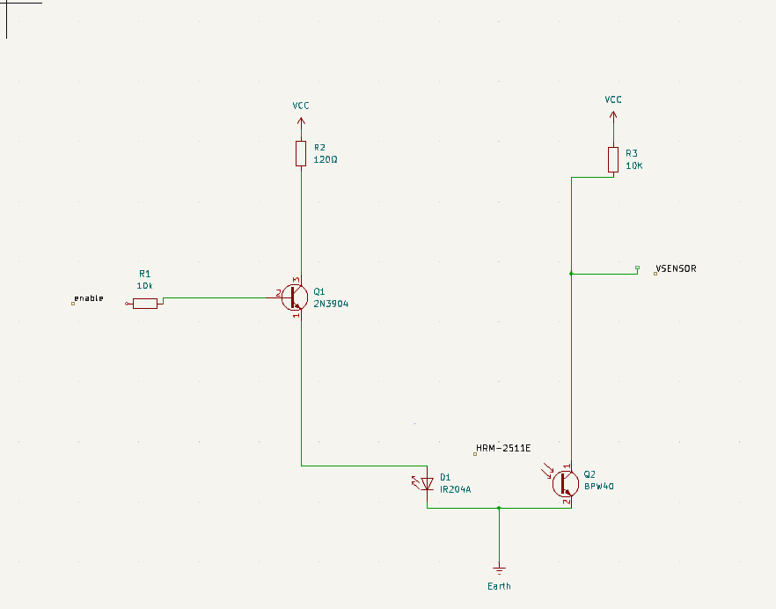

1. The following circuit shows the ON/OFF control scheme for the infra-red light source inside HRM-2511E.
2. Note that the Enable signal must be pulled high in order to turn on the IR LED.
3. The photodetector output (VSENSOR) contains the PPG signal that goes to a two-stage filter and amplifier circuit for further processing.

**Enabling the Sensor:**

* When the Enable signal is high, current flows through the 10K base resistor into the base of the 2N3904 transistor.
* This turns the transistor ON, allowing current to flow from Vcc through the 120Ω resistor, through the collector-emitter junction of the transistor, and into the LED of the HRM-2511E.
* The LED emits infrared light onto the finger.

**Detecting Pulse:**

* The phototransistor/photodiode in the HRM-2511E detects the reflected light.
* The amount of reflected light changes with the changes in blood volume due to the pulse.
* When more light is reflected (corresponding to a blood volume increase), the phototransistor conducts more current.
* When less light is reflected (corresponding to a blood volume decrease), the phototransistor conducts less current.

**Generating VSENSOR Output:**

* The 10K pull-up resistor connected to Vcc and the collector of the phototransistor forms a voltage divider.
* When the phototransistor conducts more current, the voltage at VSENSOR drops.
* When the phototransistor conducts less current, the voltage at VSENSOR rises.
* This creates a varying voltage signal at VSENSOR that corresponds to the pulse.

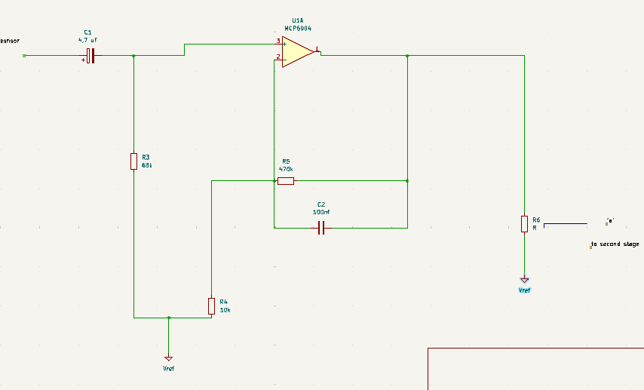

**Digital Output:**

* The VSENSOR signal is then typically fed into a microcontroller's analog-to-digital converter (ADC).
* The ADC converts the analog voltage signal into a digital value that can be processed by the microcontroller to determine the heart rate.
* The PPG signal coming from the photodetector is weak and noisy, So we need an amplifier and filter circuits to boost and clean the signal.
* In Stage I instrumentation, the signal is first passed through a passive (RC) high-pass filter (HPF) to block the DC component of the PPG signal.
* The cut-off frequency of the HPF is 0.5Hz, and is set by the values of R (=68K) and C (=4.7uF).
* The output from the HPF goes to an Opamp-based active low-pass filter (LPF).
* The Opamp operates in non-inverting mode and has gain and cut-off frequency set to 48 and 3.4Hz, respectively.
* In order to achieve a full swing of the PPG signal at the output, the negative input of the Opamp is tied to a reference voltage (Vref) of 2.0V.
* The Vref is generated using a zener diode. At the output is a potentiometer (P1) that acts as a manual gain control.
* The output from the active LPF now goes to Stage II instrumentation circuit, which is basically a replica of the Stage I circuit.
* Note that the amplitude of the signal going to the second stage is controlled by P1.
* The Opamp used in this project is MCP6004 from Microchip, which is a Quad-Opamp device and provides rail-to-rail output swing.

**DC Offset Removal (HPF):**

* The VSENSOR signal, which likely contains a DC offset and low-frequency noise, is passed through the 4.7μF capacitor.
* The capacitor blocks the DC component and low frequencies, allowing only the AC component (the pulse signal) to pass through.
* The 68K resistor pulls the AC signal towards VREF, setting the DC bias for the next stage.

**Amplification and Noise Reduction (LPF):**

* The AC signal from the HPF is fed into the inverting input (pin 2) of the MCP6004 op-amp.
* The op-amp, configured as an active LPF, provides a gain of approximately 48 and attenuates frequencies above 3.4Hz.
* This amplifies the pulse signal and removes high-frequency noise, resulting in a cleaner signal.

**Signal Adjustment (Potentiometer):**

* The output of the LPF (pin 1 of the op-amp) is connected to the potentiometer P1.
* By adjusting the potentiometer, the gain or offset of the signal can be fine-tuned before it's sent to the next stage (e.g., a microcontroller for further processing or analysis).

**Stable Reference (VREF):**

* The Zener diode and resistor combination provides a stable 2.0V reference voltage (VREF).
* This reference is used to bias the signal after the HPF and as the virtual ground for the op-amp, ensuring consistent operation.

Circuit

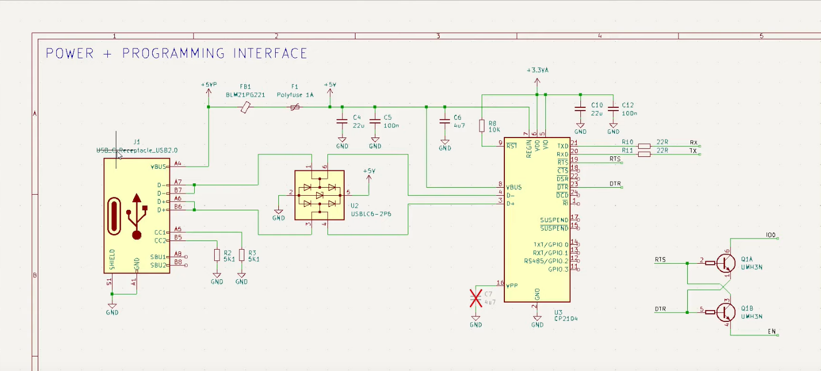

* **Power Input:** The USB connector (J1) receives power (+5V) from the USB port through the VBUS line.
* **Overcurrent Protection:** The polyfuse (BM21PG221) protects the circuit from excessive current draw.
* **Voltage Stabilization:** The capacitors (C1, C5, C6) filter out noise and provide a stable voltage supply.
* **ESD Protection:** The TVS diode array (U2) protects the USB data lines from voltage spikes.
* **Data Communication:** The USB data lines (D+, D-) are connected to the microcontroller/converter (U1).
* **Serial Communication:** The microcontroller/converter (U1) handles the USB communication and converts it to serial data (RX, TX).
* **Control Signals:** The RTS and DTR signals from the USB connection are used to control the transistors (Q1A, Q1B).
* **External Control:** The outputs of the transistors can be used to control external devices or provide status indicators.

**PCB LAYOUT**

**How it works :**

* **Light Emission:** The LED in the sensor shines light into your finger.
* **Light Detection:** The photodetector measures the amount of light that is reflected or transmitted through your finger.
* **Signal Conversion:** The photodetector converts the light intensity into an electrical signal.
* **Amplification:** The op-amp (IC2) amplifies the weak signal from the sensor.
* **Filtering and Processing:** Resistors and capacitors in the circuit filter out noise and shape the signal.
* **Pulse Detection:** The circuit detects the peaks in the amplified signal, which correspond to the pulse.
* **LED Indication:** The PULSE LED flashes with each detected pulse.
* **Output:** The VOUT pin provides an analog signal representing the pulse waveform, which can be further processed or displayed by another device.
* 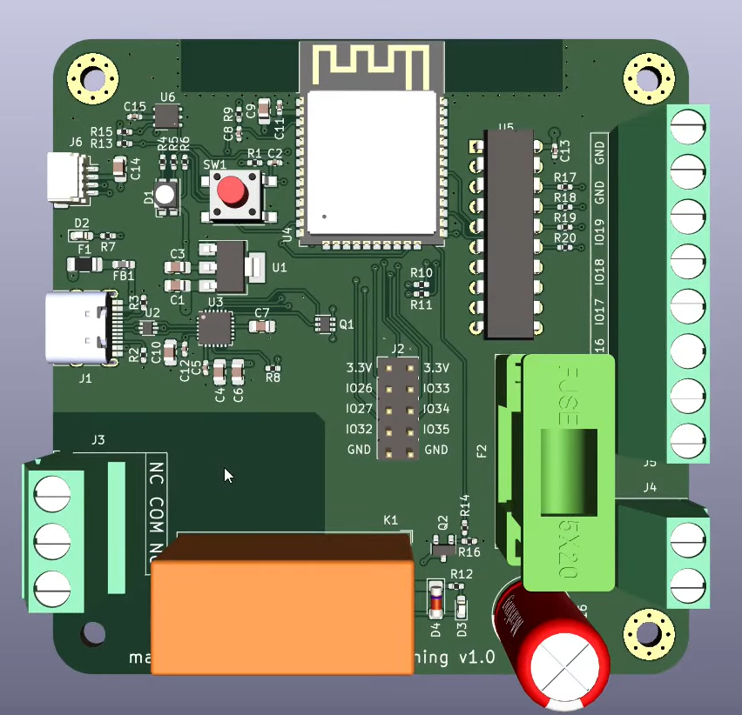

**CONCLUSION**

Easy Pulse sensor is designed for hobby and educational purposes to illustrate the principle of photoplethysmography. The new version of Easy Pulse (Version 1.1) sensor uses a transmission type sensor (HRM-2511E) that fits on finger tip and provides more stable PPG readings. The Easy Pulse V1.1 sensor provides both analog PPG and digital pulse outputs. The pulse rate information can be derived from any of the two outputs by measuring the time period of the signal. We will discuss about this more in upcoming tutorials.

**THANK YOU**

**Have a Great Day !**

Dept EECE, GST Bengaluru